ANNUAL REPORT
2023 -2024

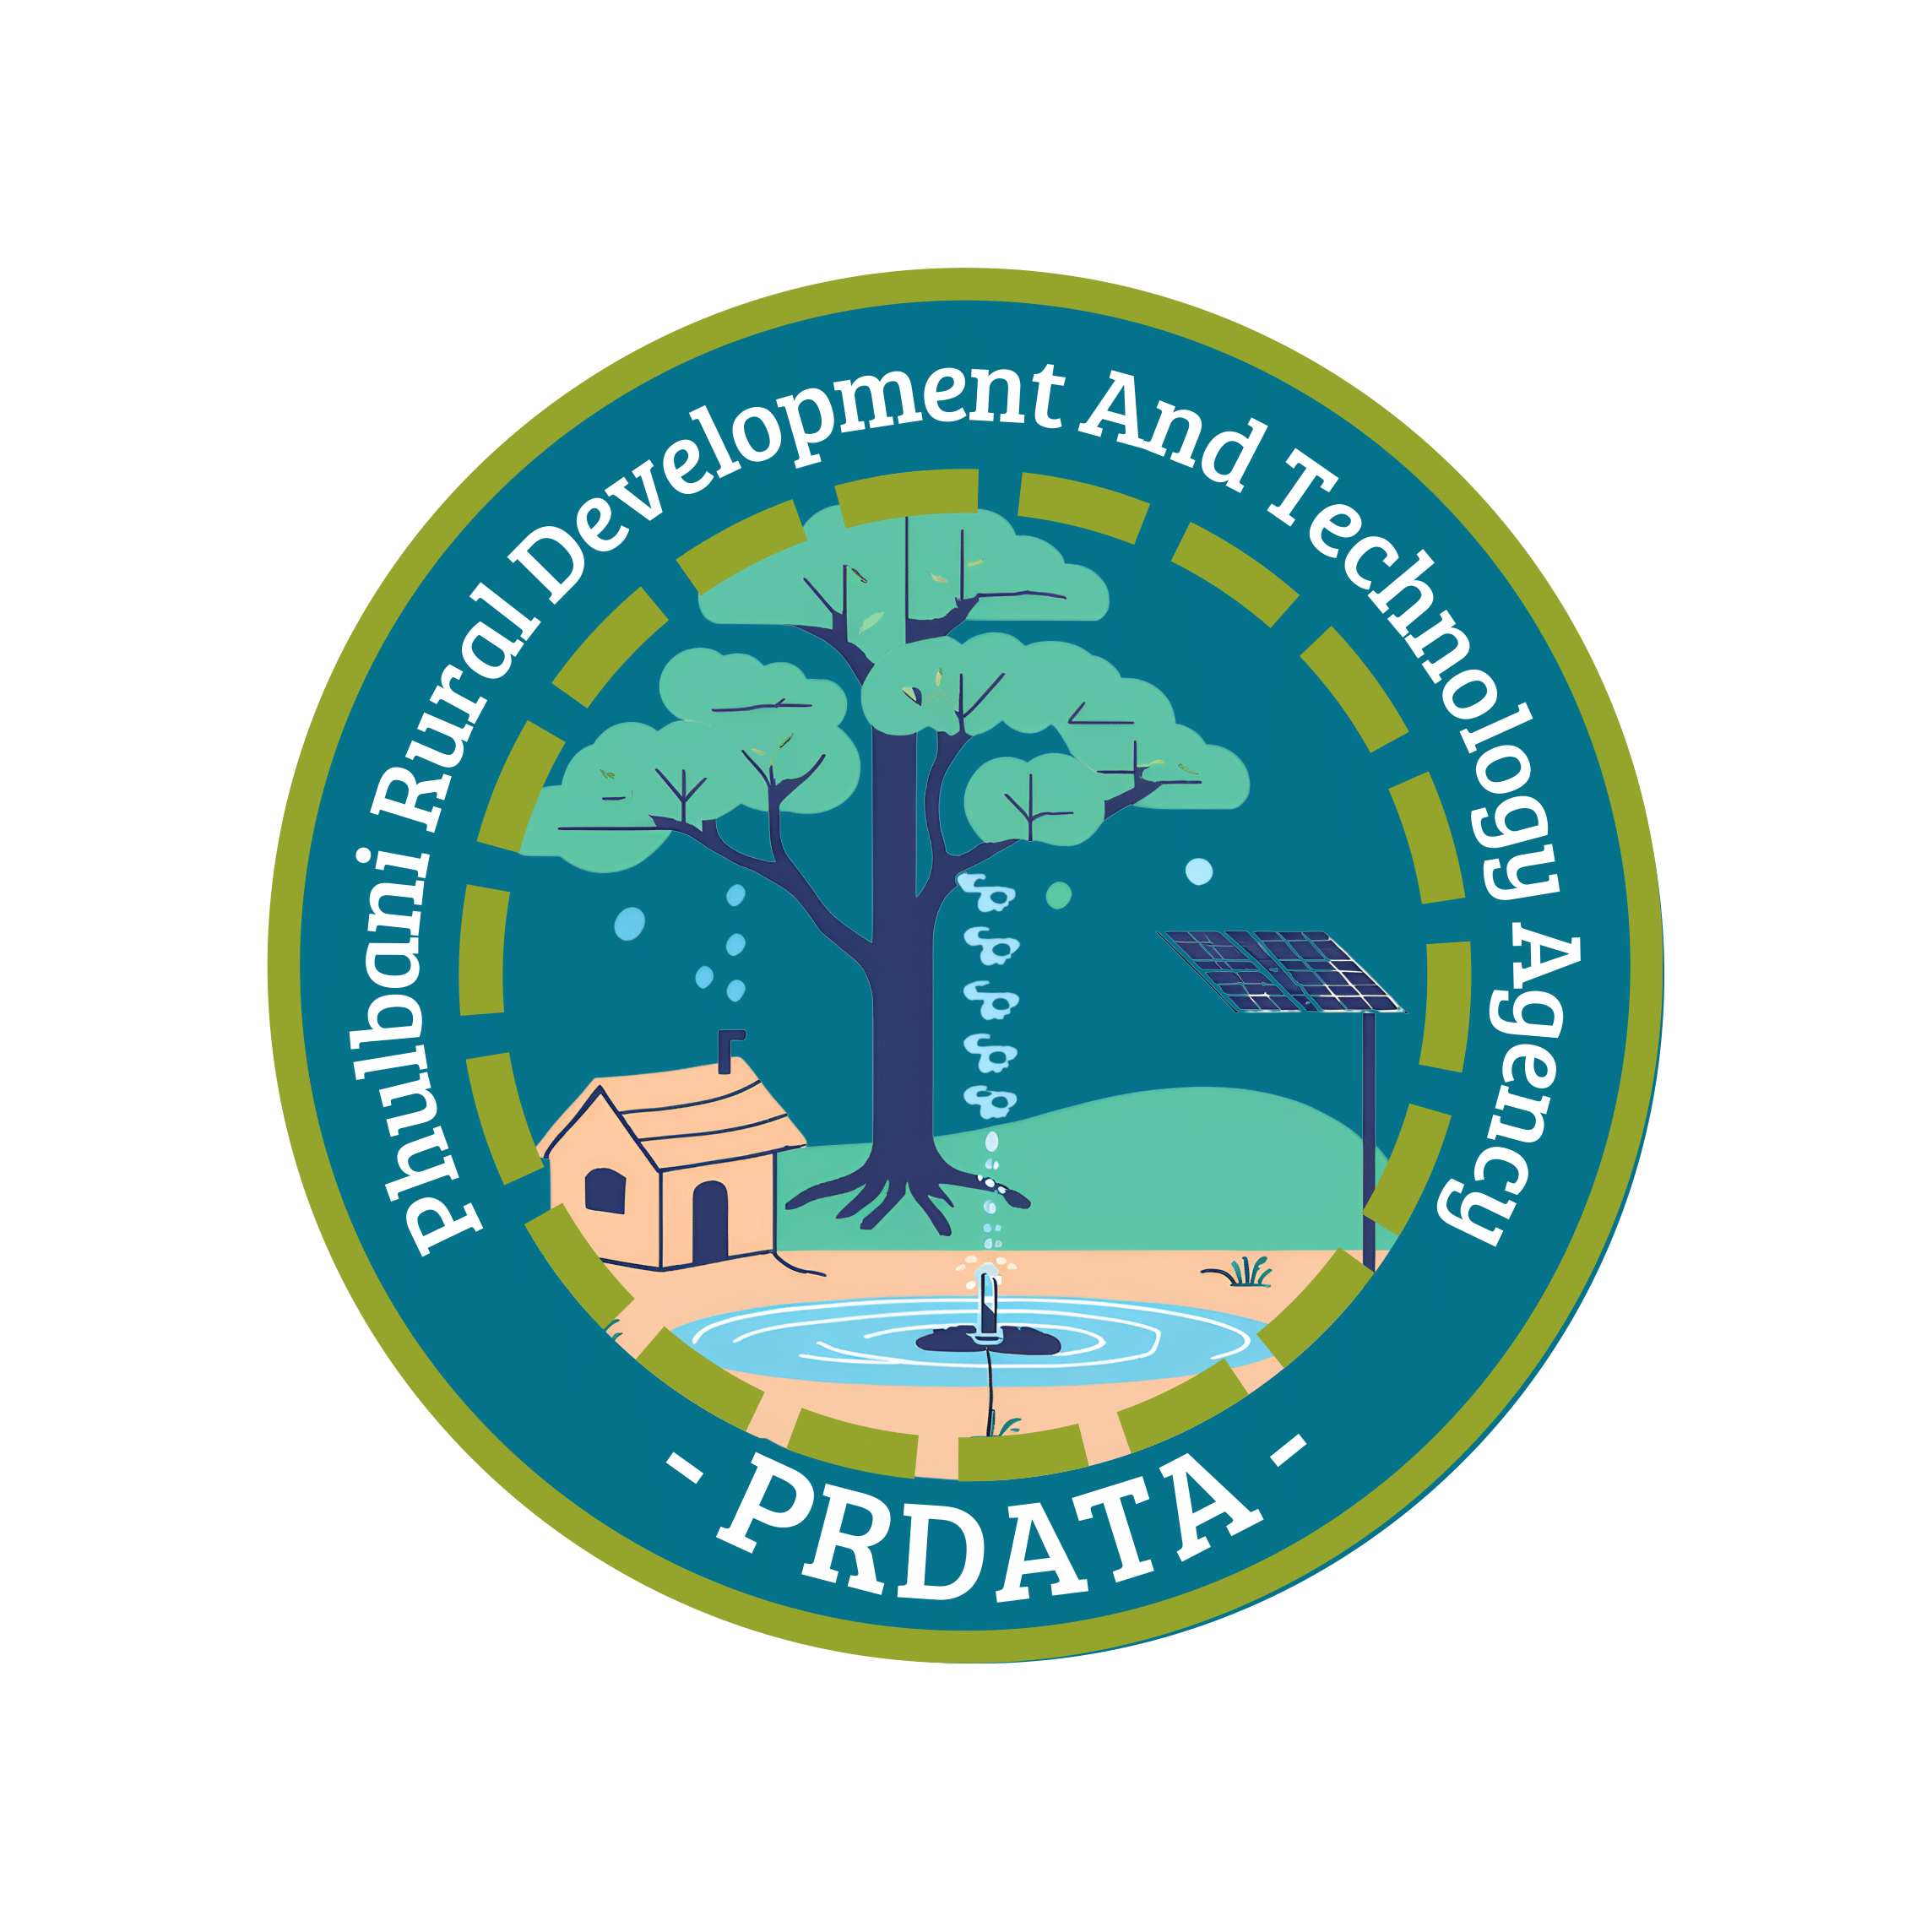
PRDATA

PHULBANI RURAL DEVLOPMENT AND TECHNOLOGY AGENCY

prdata.gud@gmail.com


8847817167; 9437061135.

www.prdata.org/

G. Udayagiri, Kandhamal, Odisha – 762 100

EXECUTIVE SECRETARY’S WORDS

As we reflect on the year gone by, I am filled with gratitude and pride for the unwavering commitment and passion demonstrated by our team, partners, and supporters. Together, we have made significant strides in advancing our mission, addressing critical challenges, and making a lasting impact in the communities.
The past year has been both inspiring and challenging. It has been a year of growth and adaptation, as we navigated new obstacles and seized emerging opportunities. We have expanded our reach, developed innovative programs, and enhanced our services to meet the ever-evolving needs of the people we support.
But none of this would have been possible without the collective efforts of our dedicated staff, volunteers, donors, and community partners. Your belief in our vision and your relentless dedication to the cause have been the driving force behind every success we have achieved.
While we celebrate the progress we’ve made; we recognize that there is still much work to be done. The challenges facing our communities remain significant, and our commitment to tackling them is stronger than ever. We are determined to continue our work, refine our strategies, and build new partnerships to further our impact in the year ahead.
Thank you for your continued trust and support. Together, we will keep pushing boundaries, breaking barriers, and creating positive change.
PRADEEP KUMAR DASH
EXECUTIVE SECRETARY
PRDATA

ABOUT THE ORGANISATION
The whole human universe is a manifestation and the impulses of the continuous struggle for civic freedom. The provocations of people’s behaviour stable the earth with an external world and build the existence of social policy to attend the balance democracy and common people civilization.
Many great personalities arrived and left their footprints. We respect them as the representatives for social reformation. A committed great personality with humble soul of our Late Paras Bhai invited a democratic civic revolution at Kandhamal District and the PRDATA is his greatness.
PRDATA get birth in the year of 1986 after the completion of the action cum research project Mother, Child and Family Welfare with the support of Family Planning Foundation of India and directly executed by AVARD Foundation for Rural Development (AFFORD), New Delhi at G.Udayagiri Block of Kandhamal District.
Paras Bhai was the key leader who associated the eminent likeminded social researcher and activist to a collective platform and associated the Governance of PRDATA as a voluntary social development agency.
PRDATA registered under Indian Societies Registration Act XXI 1860 in the date 8th May, 1986 by Register of Societies, Odisha. We have started our work from G. Udayagiri Block and presently having its working area at Kotagarh, Tumudibandha, Chakapad and G. Udayagiri Block of Kandhamal District of Odisha State.
The proclaim unbelievable reality from a sleeping face of showering clouds proved the spirit of collective work and ironic commitment and honesty with the PRDATA history.

Vision
PRDATA Visualizes a Society of self–reliant and self-sustained economic growth and social development based on appropriate and optimal indigenous resources and technology management.
Mission
To Improve Quality of Life and Livelihood options of the weaker sections of Rural Society through participatory planning and rural technology interventions and in harmony with nature.
Presence in the District
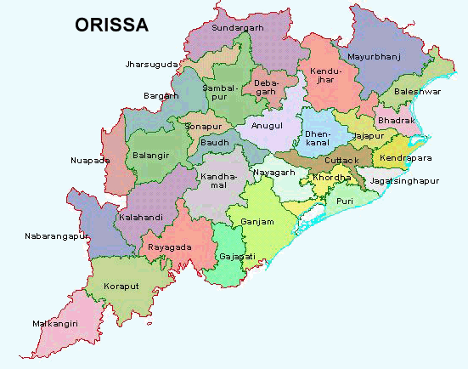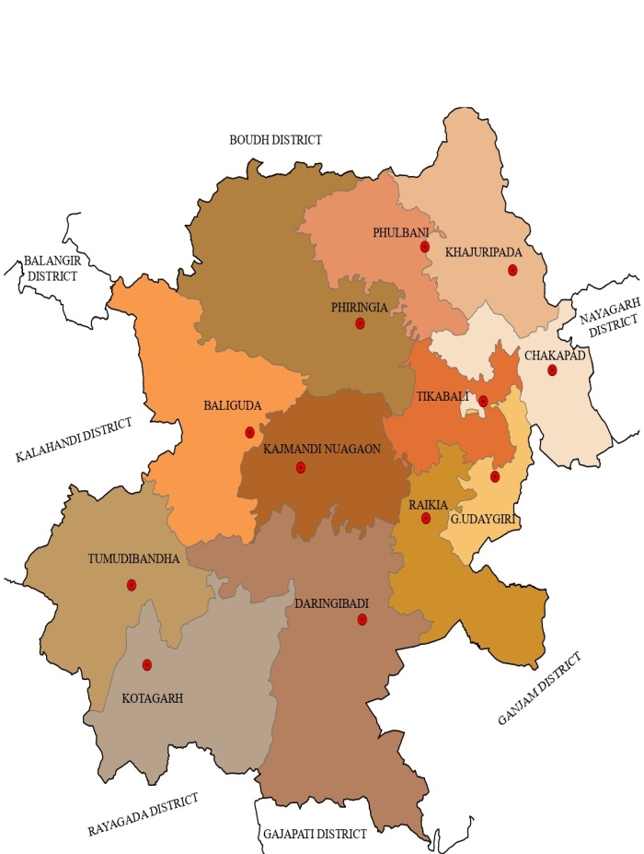
ODISHA MAP
Sl. No | Name of the Block | No. of G.P Covered | Project Implemented | No. of Village Covered / Population
01 | G.Udayagiri | 6 | Follow-up & Management of Village Institutions | 27/8947
02 | Tumudibandha | 6 | Follow-up & Management of Village Institutions | 105/ 5757
03 | Kotagarh | 6 | Follow-up & Management of Village Institutions, AROGYA Plus Program & Malaria Control Program | 77/11573
04 | Chakapad | 6 | Forest Right Act. IFR & CFR | 43/29756

ACTIVITY REPORT OF PRDATA-2023-24:
- FUNDED ACTIVITIES
- AROGYA PLUS PROGRAM:
The program aims for the providing services to the reference people through Mobile health unit called as Arogya Plus program. The team consisting of Medical Officer (AYUSH), Pharmacist, ANM(F) and attendant visiting the identified hard to reach 28 nos. villages in 4-gram panchayats namely; Srirampur, Jubaguda, Marlanga and Gugurumaha of Kotagarh Block in Kandhamal district.
The AROGYA Plus program is a strategy for delivering a set of public health services in inaccessible a conflict area like: - Preventive health, Curative health, Diagnostic services/Follow up /Referral and Community Mobilization
The program achieved the following as described in details;
- Village health Clinics: The team has attended village health clinics: | - Patients treated as follows:
  Village Health Clinic – Cases Treated:
  1 | Adult Male | 6082
  2 | Adult Female | 7412
  3 | (<18 years of age) | 4361
   | Total | 17855
  Type minor ailments treated
  1 | ARI | 3677
  2 | Diarrhoea disease | 216
  3 | Skin diseases | 1381
  4 | Suspected Malaria | 1205
  5 | Others | 11376
   | Total | 17855
- School Health program conducted in 4 Schools: | - Types of diseases:
  School Health Clinic :
  1 | No of schools planned to be visited | 40
  2 | No of Schools visited once in a month | 38
  3 | No of Schools visited twice in a month | 12
  4 | Nos. of cases treated | 1976
  Type of Minor Ailments Treated:
  1 | ARI | 477
  2 | Diarrhoea diseases | 31
  3 | Skin diseases | 374
  4 | Suspected Malaria | 67
  5 | Others | 1027
   | Total | 1976
- Malaria cases attended for treatment:
Malaria cases attended
1 | No of fever cases attended | 723
2 | RDK test done (for no of cases ) | 1293
3 | No. of them diagnosed positive | 81
4 | No of them given treatment | 81

- Follow-up of patients: The ensured the follow up activity of patients of critical diseases treated during the village health clinic. During the year 313 cases have followed up and providing health treatment.
- RCH Services: The team is assisting the ANM (govt.) in registering the ANC cases and directly visiting the PNC cases during the village health clinics. This year the team visited 157 PNC cases.
- Health Education program: Health education activities undertaken in villages as well as in the schools. During the year 2023-24, AROGYA plus team organized 44 village level health awareness and education camps in villages and 22 sessions have been organized in schools where 1790 people and 1320 students attended respectively.

- MALARIA CONTROL PROGRAM:
PRDATA ensures Early Diagnosis and Early Treatment of malaria cases in prone Malaria villages being identified by the Community Health Centre, Kotagarh. The major objectives of the programme to conduct the blood tests during the night to access the malaria cases and conduct the treatment on the spot. The intensified Malaria Control program programme implemented in 17 villages of 4 Gram Panchayats engaging 15 volunteers from the village in association of ASHA. The motto of NVBDCP every malaria case should receive a complete treatment and reducing further severity in transmission of the disease. The volunteers have taken 2567 blood samples and found 1234 positive cases that have been provided immediate treatments.

- MASS DRUG ADMINISTRATION:
The Mass Drug Administration implemented in G. Udayagiri & Chakapad blocks of Kandhamal district to create awareness among the community to take the prevention on Filaria. The programme enabled us to create volunteering opportunity where 9 nos. of volunteers were engaged for the programme. The focus of the programme was to provide awareness its effects in Anganwadi’s, schools, colleges, institutions, households and community. Volunteers of PRDATA came through with effective and coordinated plan to provide as much information about Filaria to the community and acknowledge them about the preventions and hygienic regulations to take care of their health. The MDA programme ran for a period of 45 days in which the volunteers achieved the following as described in details;
AWARENESS CAMPS AND MEETINGS IN CHAKAPAD AND G. UDAYAGIRI BLOCKS OF KANDHAMAL
SCHOOLS/ COLLEGES/ANGANWADIS | SHGs | COMMUNITY MEETINGS CONDUCTED | HOUSEHOLD
172 | 435 | 170 | 13366
MEDICINE DISTRIBUTION ACTIVITY IN CHAKAPAD AND G. UDAYAGIRI BLOCKS OF KANDHAMAL
(Refusal of Medicine Consumption)
SCHOOLS/ ANGANWADIS | COLLEGES | INSTITUTIONS | INDIVIDUALS
0 | 0 | 0 | 2646

- NIRANTHARA CLASSIC PROGRAM:
PRDATA has participated in imparting training of key staffs to enhance the capacity and efficiency for strengthening the functions (management & implementation) of the organization. This will show the visibility of the organization. Mainly, the Leader, Board Member(s), Accountant & one staff as Fund Raising Manager have been participated in the training to build the capacity in respective areas. Eight (8) modules have been selected such as: Compliances, Finance & Accounts, Governance, Human Resources, Leadership & Strategy, Marketing & Fund Raising & Donor Management, MIS & Technology and Program Management.
The program has inaugurated on 27th August, 2023 at CIWA, Bhubaneswar where 32 nos. organizations from Odisha participated.
During the period till March,2024 three (3) modules like Compliances, Finance & Accounts & Governance have been covered where, the Leader, Board Member and Accountant called as Compliances & Finance Manager (CFM) attended the training program.

- PROMOTION OF ANIMAL HUSBANDRY & LIVESTOCK FOR ECONOMIC GENERATION:
The programme enhances the capacity towards implementation of various beneficiary-oriented Animal Husbandry and Veterinary schemes and services. PRDATA in partnership with District Veterinary Office has enabled 12 nos. of Program Assistants in 12 blocks of Kandhamal, who are responsible for the management, coordination and completion of the said activity. Including that they also require to follow up on Animal Husbandry and livelihood programmes and converge with other livelihood schemes to derive maximum benefit to a farmer. They require to capture the database on beneficiaries under various AH schemes.

- NON-FUNDED ACTIVITIES
- INTEGRATING INSTITUTIONS FOR COMMON ACTION PROGRAM:
PRDATA has worked for sustenance of the institutions established/built for implementing and subsequent sustainable management of the resources created under various programs implemented in past years under Watershed Development program, Orissa Tribal Empowerment & Livelihoods program, Jeebika Program, INRM and Water & Sanitation in the 358 villages of Tumudibandha, Kotagarh, Chakapad & G. Udayagiri blocks. The total no. of 258 grassroots institutions are there who needs regular support to support & strength in getting information about the development opportunities. This year, PRDATA come across to facilitate with Gram Panchayat to take up the soil & water conservation activities in the villages with participation of the people under MGNREGA. The capacity building of 64 groups have been organized during the year with 1390 participants.

- WOMEN EMPOWERMENT & LIVELIHOOD PROMOTION:
The women collectives have been trained in Mushroom, Kitchen Garden, Mo Bagichha and exotic vegetable cultivation. 79 groups have been trained in these 4 blocks with a participant of 829 nos. Out of which 19 collectives have been taken different activities with the help of Krishi Vygyan Kendra and Mission Shakti.
- SUPPORT TO DISTRESS WOMEN AND CHILDREN:
During the year PRDATA has supported to 42 single women in getting schemes under OAP & NFS and 12 children to support for education material received from 8 generous people. 39 nos. Single women have been identified for seeking support for economic enhancement through government schemes. PRDATA will facilitate the source and support for obtaining the schemes.

- FACILITATING FOREST RIGHTS ACT FOR DIGNITY & SURVIVAL:
The 975 nos. Constituted Community Forest Resource Rights claims have been submitted in Balliguda & Phulbani SDLC and further recommended to DLC for approval. Out of which 39 Community Forest Resource Management Committees’ (CFRMC) have been constituted in Tumudibandha & Chakapad Blocks to take the conservation & plantation activities in the identified area with local forest officials.
PRDATA has indirectly participated in operationalizing the MJJY in Tumudibandha & G. Udayagiri and Chakapad block through providing manpower to implementing NGO-Vasundhara. The corrections of Records of Rights and earmarking the area under CFR is being ensured under the program.

- STRENGTHENING LOCAL GOVERNANCE & ENABLING GOOD GOVERNANCE:
PRDATA worked in the villages of 24 Gram Panchayats directly and 13 another Gram Panchayats indirectly. However, PRDATA took responsibility in providing early information and supporting the PRI members as per their requirements. In the year 2022-23, we have witnessed 37 training programs at their level. In 24-gram Panchayats our field representatives attending the meetings twice in a month.
Sl. No. | Name of Block | No. of Participants | No. of Panchayat’s covered | Remarks
1 | Chakapad | 48 | 5
2 | Tumudibandha | 53 | 7
3 | G. Udayagiri | 32 | 8
4 | Kotagarh | 14 | 4
 | Total | 147 | 24

- WORKSHOPS ON GIRL EDUCATION & PROHIBITION OF CHILD MARRIAGE:
PRDATA in association of Balya Vivaha Pratirodha Manch, Kandhamal has organized 5 workshops in Phiringia, Chakapad, G. Udayagiri, Kotagrh & Tumudibandha blocks in association with block level Balya Vivah Pratirodha Manch where 335 girls and mother have been participated.

Sl. No. | Name of Block | No. of Participants | Topics discussed
1. | G.Udayagiri | 84 | Causes of Girl Child Marriage, Different laws for prohibition of Child Marriage, Adolescent Health& Life skill training. Skill development of Gram Panchayat level Balya Bibaha Manch.
2. | Chakapad | 92
3. | Phiringia | 83
4. | Kotagarh | 45
5 | Tumudibandha | 51
 | Total | 355

- SUPPORT TO YOUTH ATTENDING SEMINAR, WORKSHOPS & MEETINGS:
PRDATA has extended its hand for awakening the Kandhamal youths in participating seminars & workshops outside the district to expose and share the experience. These youths are becoming the motivator & attribute the involvement in development works and extend the support to avail the government provisions & benefits to the eligible reference people. The youth clubs exist in these blocks are followed up and provides need-based support to strengthen.
Each year there is a Youth Mahostava being organized during 22-23 December each year by the ANTARANGA Yuva Mahasangha, Kandhamal (an association of 387 youth clubs in the district), PRDATA supports to event and process physically and financially.
In, 2023-24, The Yuva Mahostav has organised at Town Hall Balliguda on 22nd December,2024 where 300 youths from district attended. The next year’s commitment was the climate change and rejection of plastic items.
- Our FUNDERS:
- Zilla Swasthiya Samiti (ZSS)/ NHM, Kandhamal.
- CDVO, Kandhamal.
- Dhwani Foundation, Bangalore
- OUR AUDITOR:
R. C. Lal & Co.
Chartered Accountants
41, Ashok Nagar East,
Bhubaneswar – 751 009

- OUR FINANCIAL MATTER :

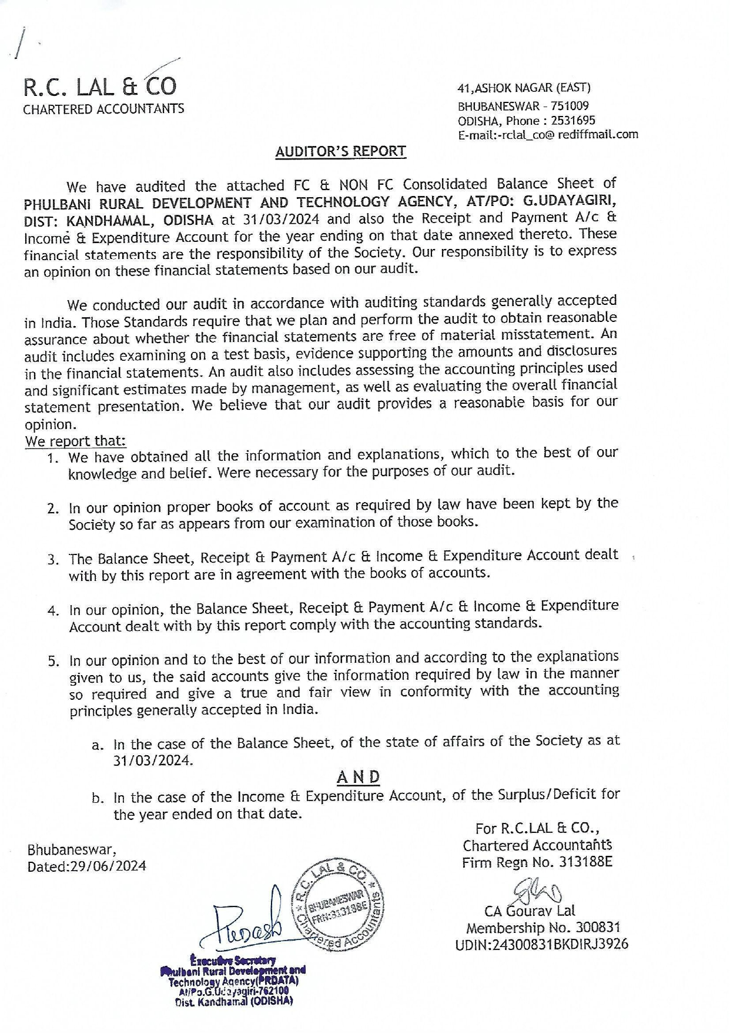
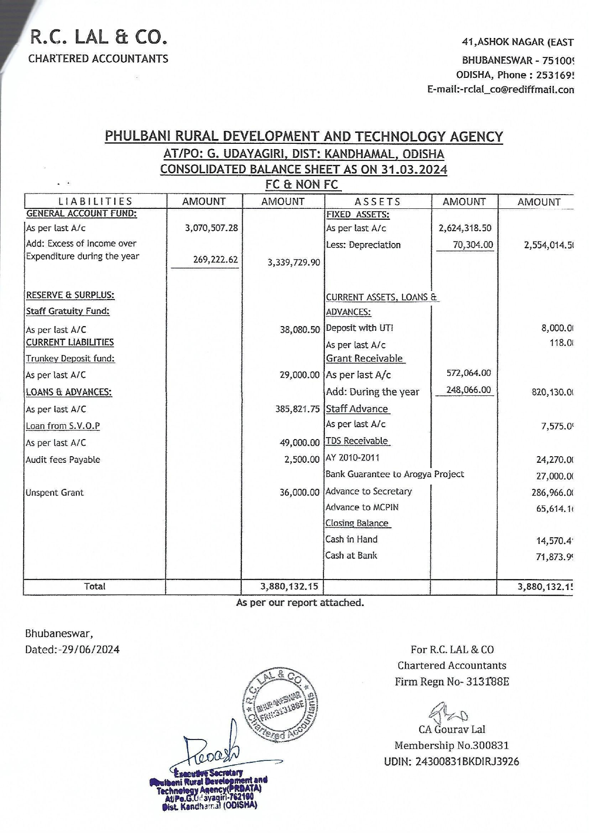
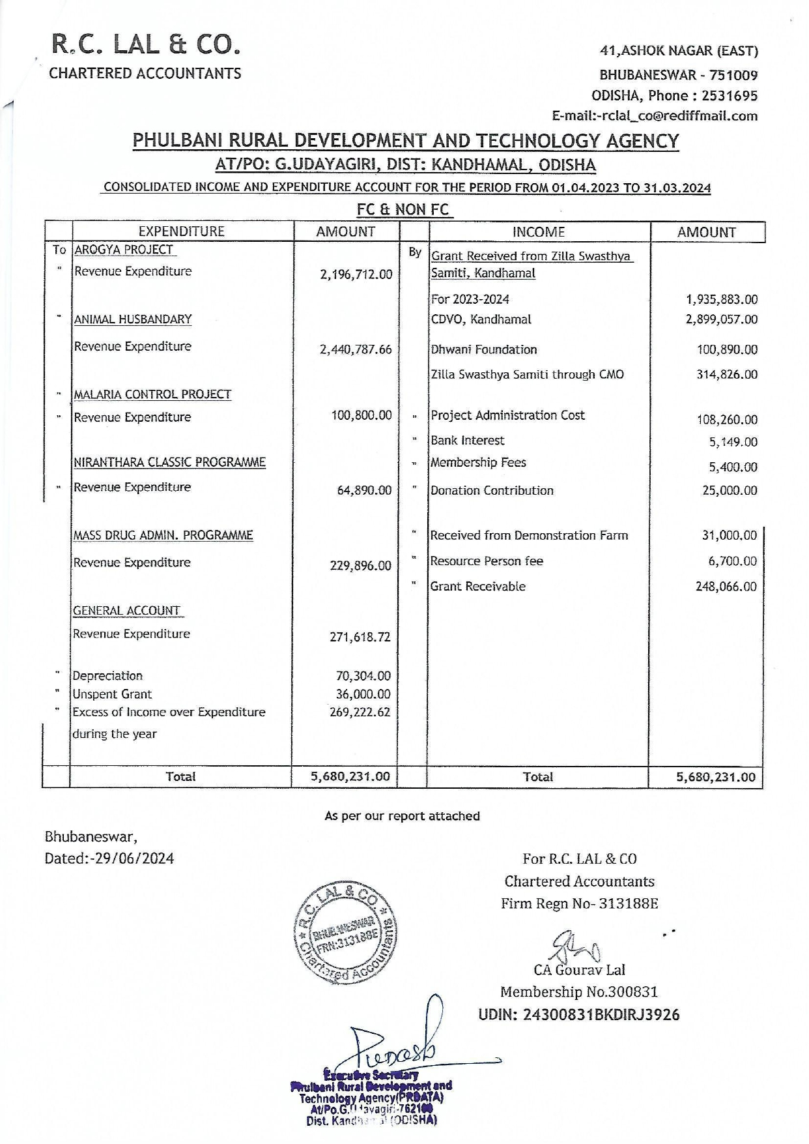
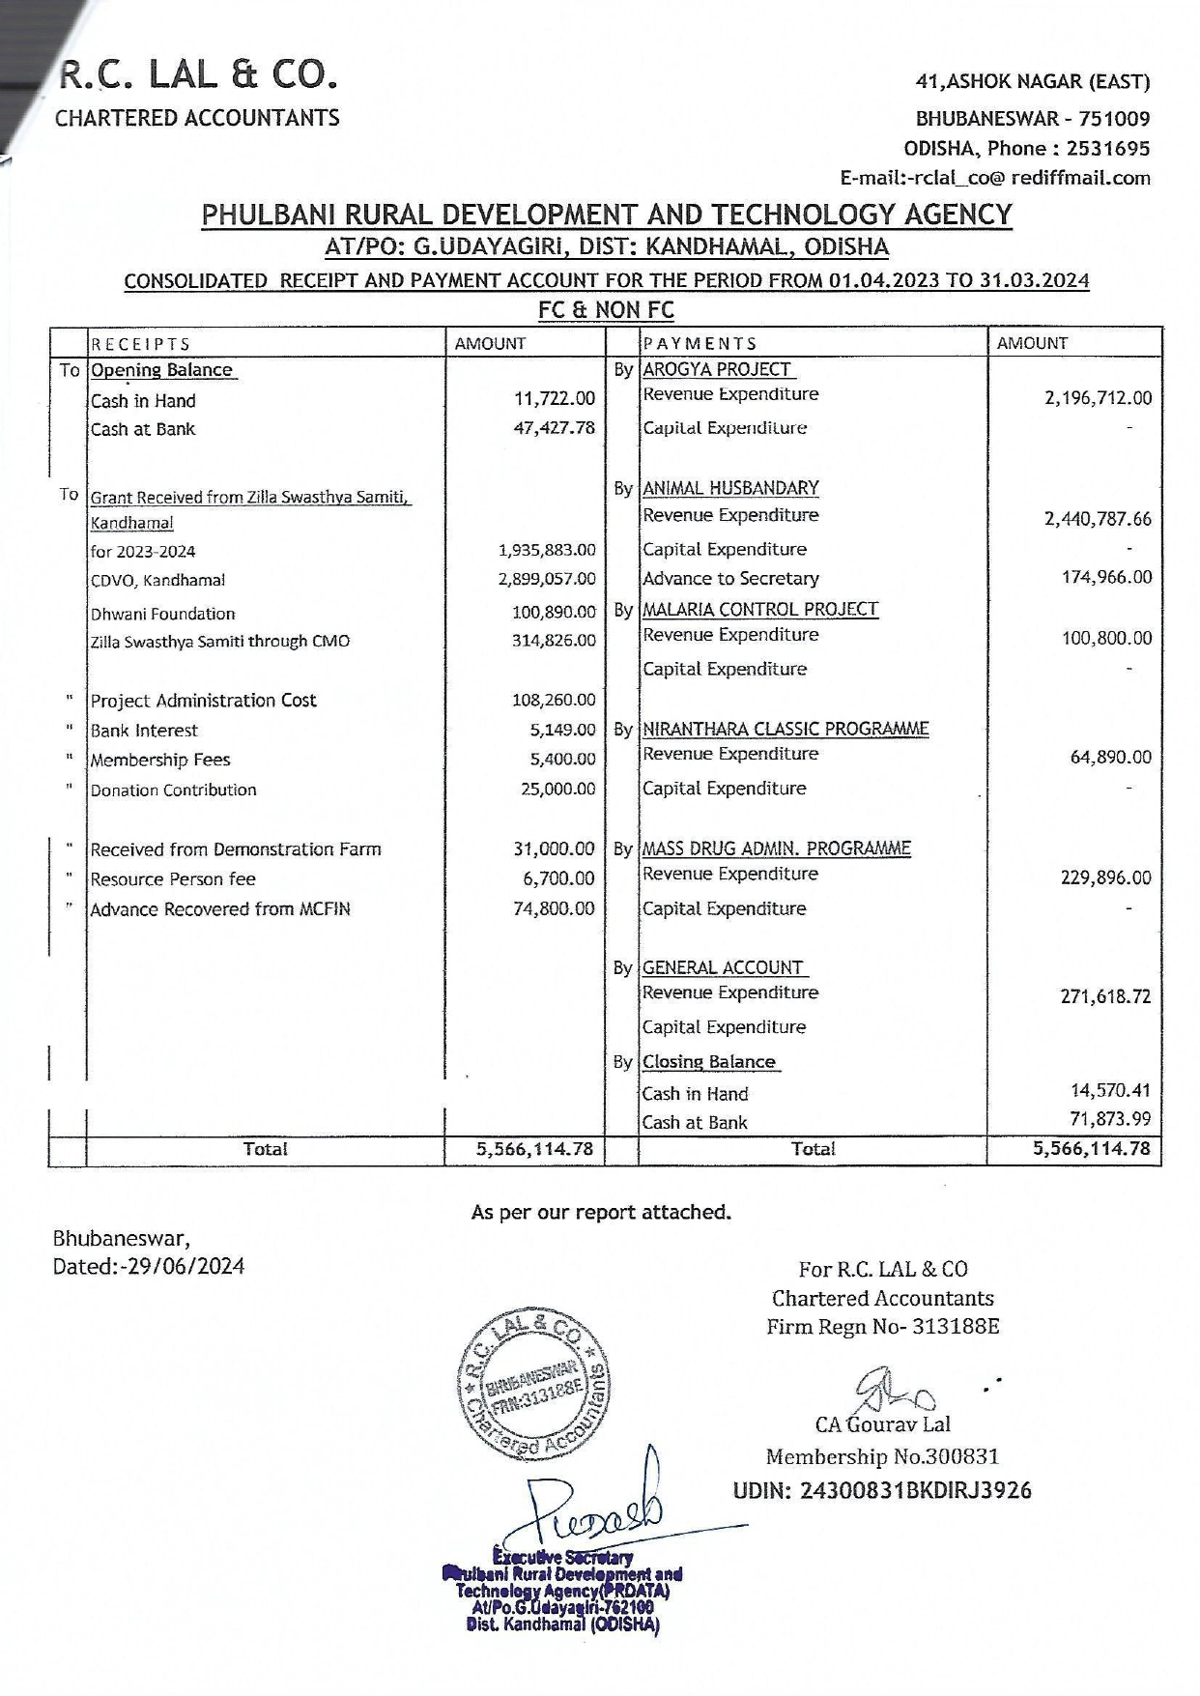
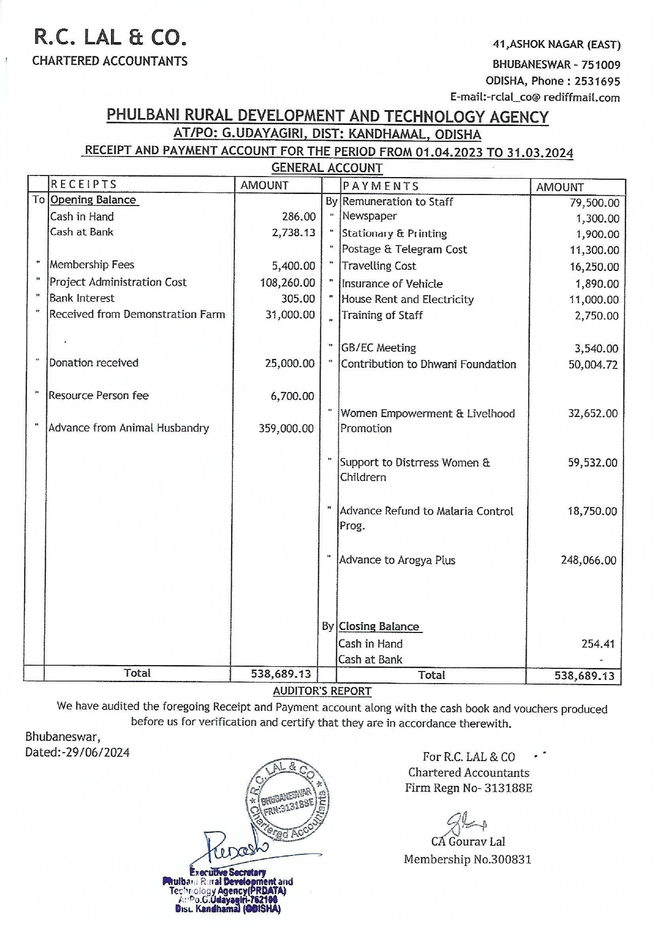
- EMPLOYEE LIST
SL. NO. | NAME | DESIGNATION | RESPONSIBILITY
1. | PRADEEP KUMAR DASH | EXECUTIVE SECRETARY | Leading PRDATA from past 22 years as a leader he has the responsibility to oversee all the working process of the organisation and provide his insights to the workings. He is the deciding authority of the plans and procedures to be undertaken in various programs. He also ensures a proper working environment for all the staffs.
2. | SAMSON NAIK | ACCOUNTANT | Associated with PRDATA for 15 years as an accountant. He is responsible for maintain of the accounts, payments and record keeping, any other finances and compliances of the organisation.
3. | PRATEEK KUMAR DASH | PROGRAM MANAGER | He is responsible for the ongoing activities of PRDATA in the field and prepare & provide data, reports of the program and to see that the objectives of the given program are executed properly and orderly.
4. | NILAMADHABA PATRA | PROGRAM EXECUTIVE | Working with PRDATA since past 8 years. He is looking after educational activities and Capacity Building of staff & community of PRDATA
5. | DR. SANJAYA KUMAR MISHRA | DOCTOR | Team Head of AROGYA Plus Programme (Mobile Health Unit).
6. | PILATA MUTHAMAJHI | PHARMACIST | Pharmacist with AROGYA Plus Programme. (Mobile Health Unit)
7. | RASMI PRAVA MAHANTA | ANM | ANM with AROGYA Plus Programme. (Mobile Health Unit)
8. | LAXMAN KUMAR PANDA | ATTENDANT | Working as attendant in AROGYA Plus Programme. (Mobile Health Unit)
9. | IPSITA PATTNAIK | PROGRAM ASSITANT (s) | Working as support staff to the Block Veterinary Officer engaged in 12 blocks of Kandhamal for Strengthening Animal Husbandry & Veterinary Services at Block Level. Performing Data Entry, Livestock based livelihood extension activities and monitoring the program at the block level
10. | MIKI MOHAPATRA | PROGRAM ASSITANT (s)
11. | ANIL KUMAR NAYAK | PROGRAM ASSITANT (s)
12. | DIPTI RANJAN BEHERA | PROGRAM ASSITANT (s)
13. | SAUMYA RANJAN PRADHAN | PROGRAM ASSITANT (s)
14. | SUBRATA PRADHAN | PROGRAM ASSITANT (s)
15. | SUPRAVA PRADHAN | PROGRAM ASSITANT (s)
16. | ABINASH PATTNAIK | PROGRAM ASSITANT (s)
17. | JOTHAN DIGAL | PROGRAM ASSITANT (s)
18. | DIBYARANJAN PRADHAN | PROGRAM ASSITANT (s)
19. | JAYARAM NAYAK | PROGRAM ASSITANT (s)
20. | KUNA BEHERA | PROGRAM ASSITANT (s)

CONCLUSION

As we reflect on the past year, we are filled with gratitude and pride for the progress we’ve made in advancing our mission to [insert mission of the NGO, e.g., promote education, provide healthcare, protect the environment]. This year has been one of both challenges and triumphs, and none of our achievements would have been possible without the unwavering support of our donors, volunteers, partners, and the communities we serve.
Through our collective efforts, we have touched countless lives, created lasting change, and empowered individuals to rise above adversity. We remain deeply committed to our vision of [insert vision of the NGO, e.g., creating a world where every child has access to education, ensuring health and dignity for all].
Looking ahead, we are excited to continue building on the strong foundation we have established, while embracing new opportunities and innovative approaches to address the evolving needs of those we serve. We pledge to uphold our values of transparency, accountability, and compassion, ensuring that every contribution—whether time, talent, or resources—directly supports our programs and initiatives.
We are profoundly grateful for the trust and dedication of all those who have joined us on this journey. Together, we will continue to make a meaningful impact and create a brighter future for all.
Thank you for your continued support and belief in our work.

EXECUTIVE SECRETARY
PRDATA

